Ministry of education and science of the Russian Federation
Peter the Great Saint Petersburg Polytechnic University
National Simulation Society
EuroSim European Association
MvSoft Company
Group of TRANSAS Companies

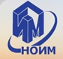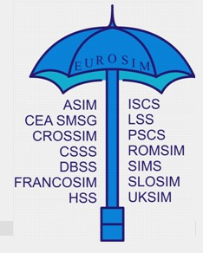

National Scientific and Technical Conference

Computer modeling and simulation - 2017
(COMOD-2017)

3 - 4 July, 2017
Saint Petersburg

Chairman of the Conference

Prof. V.S. Zaborovsky (Saint Petersburg)

Program Committee

Prof. R.M. Yusupov, corr. member of the RAS (Saint Petersburg)  Prof. F. Breitenecker (Austria)  Prof. Yu.B. Kolesov (Moscow)  Prof. N.V. Korovkin (Saint Petersburg)  Prof. E.A.Novikov (Krasnoyarsk) | Prof. V.A. Ryzhov (Saint Petersburg)  Prof. S.N. Pozdnyakov (Saint Petersburg))  Prof. Yu.V.Shornikov (Novosibirsk)  Prof. N.A.Tseligorov (Rostov-on-Don)  Prof. A. Urkia (Spain)  Prof. G. Zacharewicz  (Bordeaux,France)

Organizing Committee

Chairman
Prof. Yu.B. Senichenkov (Saint Petersburg)

Organizing Committee Members
Prof. V.V. Korablev (Saint Petersburg)

A.L. Smirnova - Head of Dept. (Saint Petersburg)

The purpose of the conference
We invite developers of the modern media of visual simulation of complex dynamic systems and users of these systems to talk about their advance in this area, share your experience, and tell about achievements.
We are particularly looking for a youth.

National Scientific and Technical Conference will be held on 3-4 July, 2017

in the Peter the Great Saint Petersburg Polytechnic University.
The Conference working languages are Russian and English.

Reviewing the reports will be of two stages
- first - selection of the reports to be presented at the conference;
- second (after the conference) – the reports will be selected and recommended for publication (after completion) in the following journals:
«University Scientific Magazine»
«Scientific and Technical News of SPbPU»
«Computer Tools in Education»

Proceedings will be registered in the RSCI (Russian Science Citation Index)

The Conference Sections

- Development and application of visual modeling environment of complex
dynamic systems;
- Numerical modeling of complex dynamic systems;
- Modeling in electrical engineering and electric power industry;
- Computer tools in education.
- Projects of young scientists;
- Author's presentation of:
- new books;
- software systems;
- planned and completed theses;
- lectures about the software products.

Conference Proceedings will be presented on USB flash drive.
Hard copy of the Proceedings will be available upon prior request at the Organizing Committee for an additional fee (800 rub.)

How to submit abstracts and papers at the conference
All abstracts/papers are accepted only via the conference-machine .easychair.org. To submit abstract/paper, the author must register on the conference page in the conference machine at https://easychair.org/conferences/?conf=comod2017, get login and password, visit the conference page and upload your abstract and/or paper.
All downloaded materials should be submitted as pdf files..

Rules for abstracts and papers
All abstracts/reports must be submitted in strict accordance with the template: http://dcn.icc.spbstu.ru , section Conference/COMOD-2017.

Important dates

- 1st May 2017 – deadline for the final version of the report submission
- Notification about your paper acceptance you will receive two weeks after the upload of the final version of the paper.
Conditions for participation in the Conference
National Scientific and Technical Conference will be held on 3-4 July, 2017 in Peter the Great St. Petersburg Polytechnic University (room 118 of the Main Education Building).
Address: ul. Politekhnicheskaya 29 ("Politekhnicheskaya" metro station).

Registration fee includes: a conference set with the Conference Proceedings on CD, coffee –breaks and lunches
At an additional cost and only on request participants can enjoy:
- a bus tour around Saint-Petersburg and also excursion along the rivers and canals of St. Petersburg with a gala dinner on shipboard.
- tours to Peterhof and Tsarskoye Selo (Catherine Palace and Park with visiting the Amber room).
These events are held at an additional cost.

To participate in the Conference:
send the registration form to the email address: COMOD-2017 @spbstu.ru
File name with a registration form must include the name and initials of the participant. For example: ivanov_ak_reg.

Registration fee
Foreign participants - 350 euro

Postgraduate students and students - 150 euro

Payment methods

For EUR

Intermediary bank:
SWIFT:
Beneficiary’s bank: Bank «Saint-Petersburg» PJSC
64A Maloohtinsky Prospect, St.Petersburg 195112,
Russian Federation
SWIFT: JSBSRU2P
Beneficiary: account 40503978490550200001
Peter the Great St. Petersburg Polytechnic University (SPbPU),
29, Polytechnicheskaja str, St Petersburg,
Russian Federation

In the payment by bank transfer, please do not forget to write the title of the Conference (COMOD-2017) and your name.

All information on bank accounts see also on the Conference website: http://dcn.ftk.spbstu.ru, section Conference/COMOD-2017

You can pay by bank transfer or by cash at registration (in rub).
Participants wishing to pay by a bank must cover transaction charges.

Accommodation

Hotel accommodation is paid by the conference participants.
1. Hotel "Sputnik" *** (Prosp. Morisa Toreza 36,“ Ploschad‘ Мuzhestva“ metro station)
2.University Hotels**
-Lesnoy prospekt 65-67,“Lesnaya“ metro station
-Grazhdanskiy prospekt 28,“Akademicheskaya“ metro station.

NB: Hotel reservation is carried out through the Conference Organizing Committee. The Organizing Committee has arranged special (discounted) prices, and guarantees a proper accommodation for the Conference participants.

Information for contact
Organizing Committee of SPbPU
ul. Politekhnicheskaya 29

195251 Saint Petersburg

Russian Federation

General information:
Alla L.Smirnova
Tel/fax: +7 (812) 297 20 88

expert@spbstu.ru

Lidia Papina
Tel/fax: +7 (812) 552 85 34
COMOD-2017@spbstu.ru

Abstracts/papers submission:
Yuriy B. Senichenkov
Tel/fax: +7 (812) 297- 16 39
+7(812) 297 07 29

cm_org@dcn.icc.spbstu.ru

Conference website: http://dcn.ftk.spbstu.ru, section Conference/COMOD-2017 and http://www.spbstu.ru/conference/2017/2017.asp

COMOD-2017
Registration Form

Title:

Last Name

First Name

Other Names

Date of birth

Place of birth

Citizenship

Passport number

Date of issue

Date of expiry

Country of permanent residence

Place of visa obtaining (issuing)

Place of work:

Organization

Address

Position

E-mail

Fax

Phone

Accompanying person, if any

Date of arrival

Date of departure

Accommodation needed: | Yes No

Please note! Copy of the first page of your passport sent by fax or by e-mail is necessary for visa proceedings. Visa support letter (official invitation) will be sent to you within 2 months (for members from EU countries within 2 weeks).

Booking the hotel:
Hotel “Sputnik”
- single room
- double room

Address: Hotel “Sputnik”- Prosp. M.Toreza 36; “Ploshchad’ Muzhestva” metro station

2.University Hotels**:
Lesnoy prospekt 65-67;Lesnaya“ metro station
single room
double room

Grazhdanskiy prospekt 28; Akademicheskaya“ metro station
single room
double room

Date and Place________
Signature ____________

- Hotel “Sputnik”- Prosp. M.Toreza 36; “Ploshchad’ Muzhestva” metro station

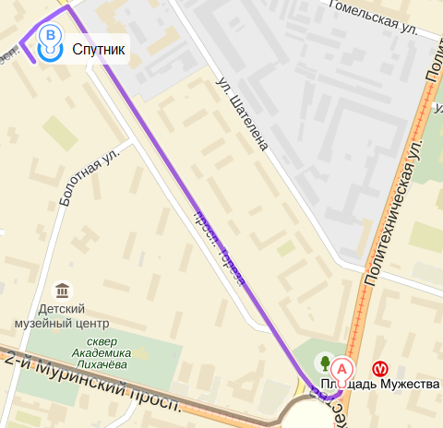

- University Hotels**:
Lesnoy prospekt 65-67,“Lesnaya“ metro station

- Ст. метро «Лесная», Лесной просп., 65.
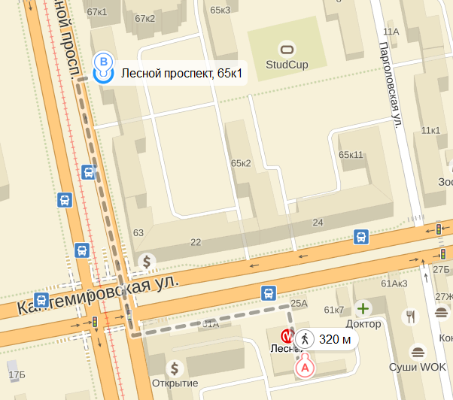

- Grazhdanskiy prospekt 28, «Akademicheskaya» metro station.

