Текст для страницы https://english.spbstu.ru/education/programs/internships-jobs-international-students/internship-ects-credits-russia/

Internship & ECTS credits in Russia

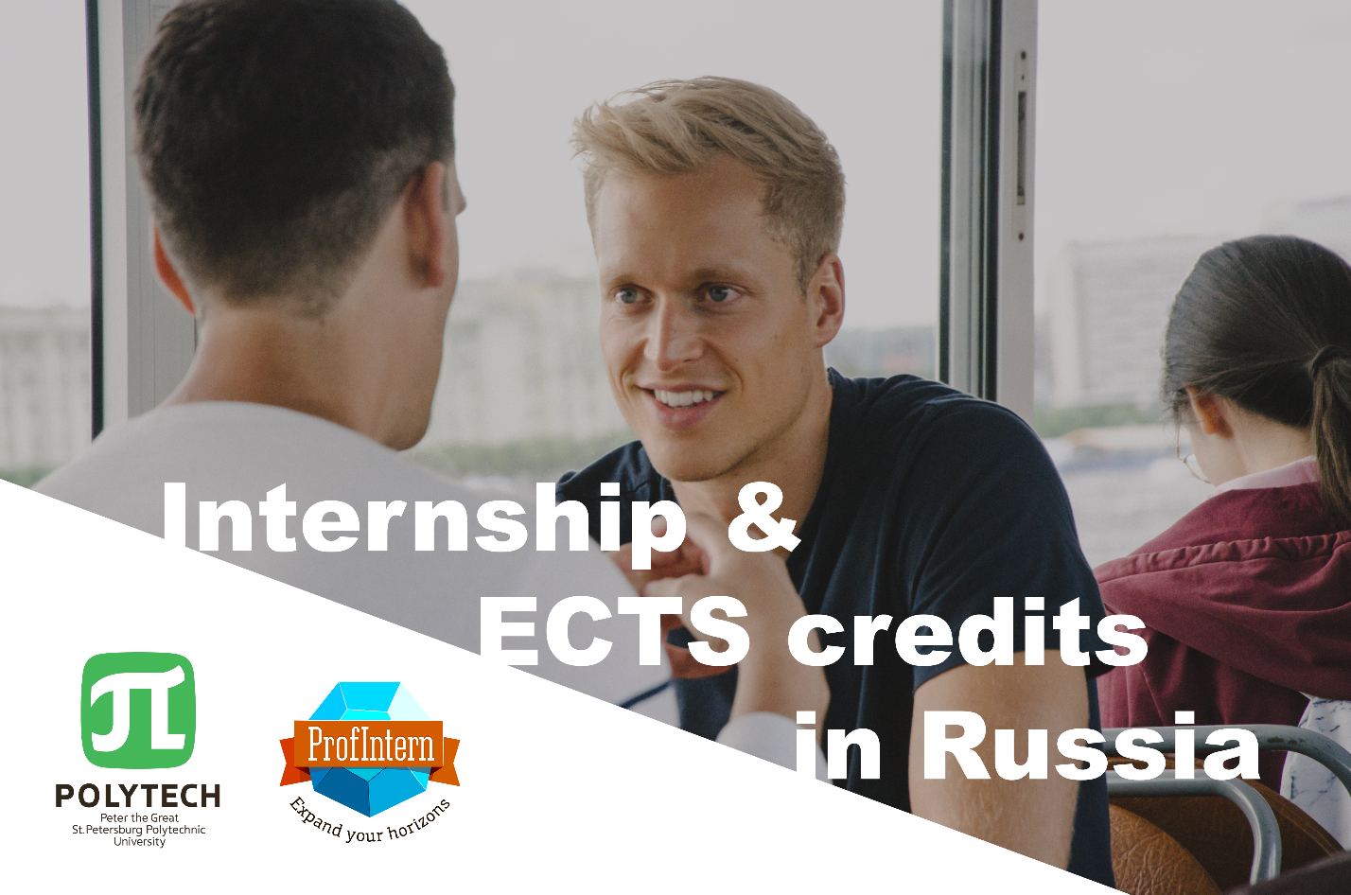

The program gives you 2 in 1:
- professional internship in Russia
- academic course on cross-cultural communication in Russian business environment

ECTS credits: 12-30
The program is available in both on-site and online formats.
About ProfIntern, the program partner:

For almost 10 years ProfIntern helps international students and recent graduates to get an overwhelming professional experience in the requested field and combine it with complete immersion in Russian culture.

The internship program consists of:
- A one-week educational course “International communication in Russian Business Environment” (at the beginning of the program);
- 11 weeks of a tailor-made internship (or longer). Personalized internship placement is based on candidate's background, skills and career plans (full day or part-time)
- Visa support including the university letter of Invitation;
- Host Company Reference
- YouTube video lessons about Russia: history, modern Russia, employment
- 24/7 support
- Dedicated Program Advisor
- Pre-departure materials
- CV and motivation letter revision + providing recommendations for their improving
- Short internship report (1-2 pages) with emphasis to the course topic (at the end of the program).

Content of the course “International communication in Russian Business Environment”
- Basic theories on Communication, Culture and their practical application to Russian culture
- Cultural Values, Language
- Verbal and Nonverbal Communication Patterns in Russian business environment
- Essay at the end of the program (to apply your new experience on cross-cultural communication received during your internship in a Russian company)
The detailed syllabus of the course in a PDF file.

Tuition fee: 1560 euro.
Optional services (to be paid extra):
- Welcome pack for your arrival (with airport pick-up, transfer, SIM-card option, 1-month transport ticket) - 105 euro;
- Accommodation (single room in a shared apartment) - 550 euro per month.

Payment procedure:
The downpayment of the tuition fee is a part of application process and is to be paid after the interview:
- 500 euro for the tuition (without accommodation)
OR
- 500 euro for the tuition + 350 euro for accommodation.
The rest is to be paid due 10 days before your program starting date.

Program schedules (4 annual intakes)

SUMMER 2022 (ON-SITE or ONLINE)
Application deadline: April 11
Arrival dates: June 17-19
Program start: June 20
Internship start: July 27
Program end: September 09
Departure dates: Sep 10-14

FALL 2022 (ON-SITE or ONLINE)
Application deadline: July 18
Arrival dates: Sep 23-25
Program start: Sep 26
Internship start: Oct 03
Program end: Dec 23
Departure dates: Dec 24-28

WINTER 2023 (ON-SITE or ONLINE)
Application deadline: Nov 07
Arrival dates: Jan 13-15
Program start: Jan 16
Internship start: Jan 23
Program end: April 07
Departure dates: April 08-12

SPRING 2023 (ON-SITE or ONLINE)
Application deadline: January 23
Arrival dates: Mar 31 – Apr 02
Program start: April 03
Internship start: April 10
Program end: June 23
Departure dates: June 24-28

Entrance requirements:
- Status of an undergraduate (3+ year), graduate, postgraduate student or a higher educational institution graduate
- English C1 (CEFR system), knowledge of other languages is highly desirable
- Compliance of the chosen internship field to the profile of education or past professional experience
- Initiativity, proactivity, responsibility
- Ability to adapt to the international working environment
- Diligence and focus on results

Main steps of your program implementation
- 1

1- APPLICATION
  - Fill out the application form
  - Send us your copy of passport, CV, motivation letter in Russian or English
  - Undergo an interview
  - Receive an invoice and make a downpayment
- 2

2- BEFORE YOUR ARRIVAL:
  - You receive a Letter of Invitation from SPbPU Polytech and enclose it to your application at a Russian Consular Office in your country to obtain one-entry student visa*
  - You receive an internship offer, describing the placing company, project and your internship tasks
  - Choose accommodation options with ProfIntern and Polytech
  - Get ready for a trip using our pre-departure guide
  - Book your plane tickets and start your trip
* There is an option of a multiple entry student visa for extra fee (upon request).
- 3

3- UPON ARRIVAL:
  - You are get picked up and transferred to your accommodation place (optional service)
  - Have an orientation meeting with your managers from Profintern and SPbPU Polytech (documents for migration registration are to be submitted at the meeting)
  - Start your program
- 4

4- BEFORE DEPARTURE:
  - Submit your final essay to the lecturer of the course «International communication in Russian Business Environment»
  - Inform SPbPU Polytech on your departure date (for migration registration and university enrollment cancellation)
  - Get your final documents (certificate with ECTS credits, host company reference letter)

A PDF presentation with details of the program and internships options.
Contacts
- polytech.profintern.com
- Zarina Asadova (SPbPU)
- asadova_za@spbstu.ru
- ProfIntern
- intern@profintern.com
- +7 (812) 534-25-31
- room 227, 28, Grazhdanskii prospect, 195220, St.Petersburg, Russia

