Documents for visa extension

- original documents (passport, migration card, registration, fingerprinting, medical examination and insurance)*

- copies of documents: (migration card, registration, fingerprinting, medical examination and insurance)*

- 2 copies of all pages of passport (1 copy for private address)

- 2 copies of registration slip (1 copy for private address)

- 2 color photos 3,5*4,5 cm

- a payment receipt of state duty (via Sberbank)

- an extract from the order

## - a certified copy of the enrollment contract (for students who study on a fee-paying basis) or a copy of the referral letter, issued by the Ministry of Education and Science of Russia certified at the Educational Department (for the quota students)

- a copy of documents (must be placed on one A4 sheet of paper):

|  |  |
| --- | --- |
| 1st page of passport | Migration card |
|  | Current visa (if available) |

А4

*If the results of the medical examination and fingerprinting are not yet available, you must bring **a copy of the Referral for documents that you received during medical examination.**

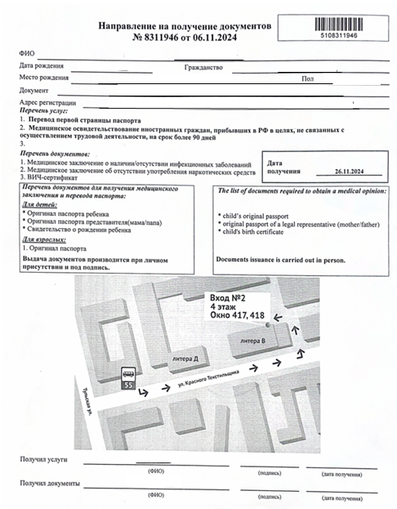

*Only students with a full set of documents will be accepted for visa extension.